Lab Exercise 13 –Provisioning an EC2 Instance on AWS
Prerequisites: Terraform Installed: Make sure you have Terraform installed on your machine. Follow the official installation guide if needed.
AWS Credentials: Ensure you have AWS credentials (Access Key ID and Secret Access Key) configured. You can set them up using the AWS CLI or by setting environment variables.
Exercise Steps:
Step 1: Create a New Directory:
Create a new directory for your Terraform configuration:
“Terraform-Demo”
Step 2: Create Terraform Configuration File (main.tf):
Create a file named main.tf with the following content:
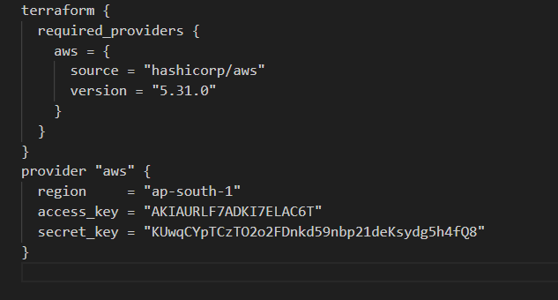
This script defines an AWS provider and provisions an EC2 instance.
Step 3: Initialize Terraform:
Run the following command to initialize your Terraform working directory:
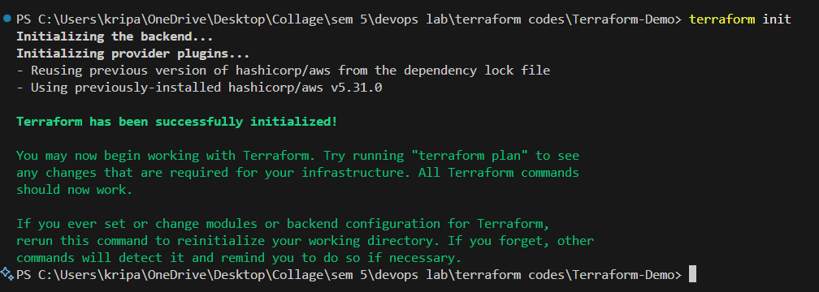
Step 4: Create Terraform Configuration File for EC2 instance (instance.tf):
Create a file named instnace.tf with the following content:
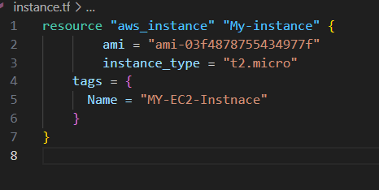
Step 5: Review Plan:
Run the following command to see what Terraform will do:
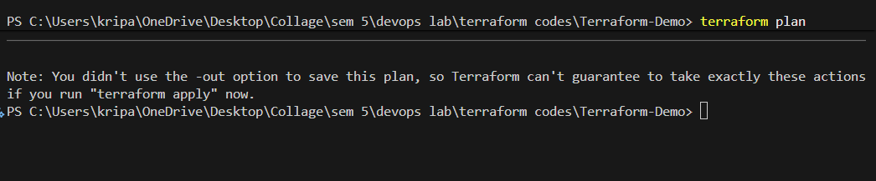
Review the plan to ensure it aligns with your expectations.
Step 6: Apply Changes:
Apply the changes to create the AWS resources:
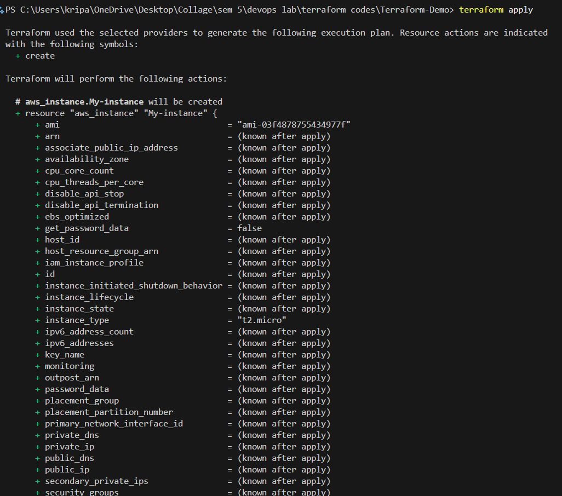
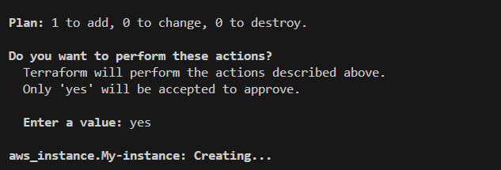

Step 7: Verify Resources:
After the terraform apply command completes, log in to your AWS Management Console and navigate to the EC2 dashboard. Verify that the EC2 instance has been created.
Step 8: Cleanup Resources:
When you are done experimenting, run the following command to destroy the created resources:
